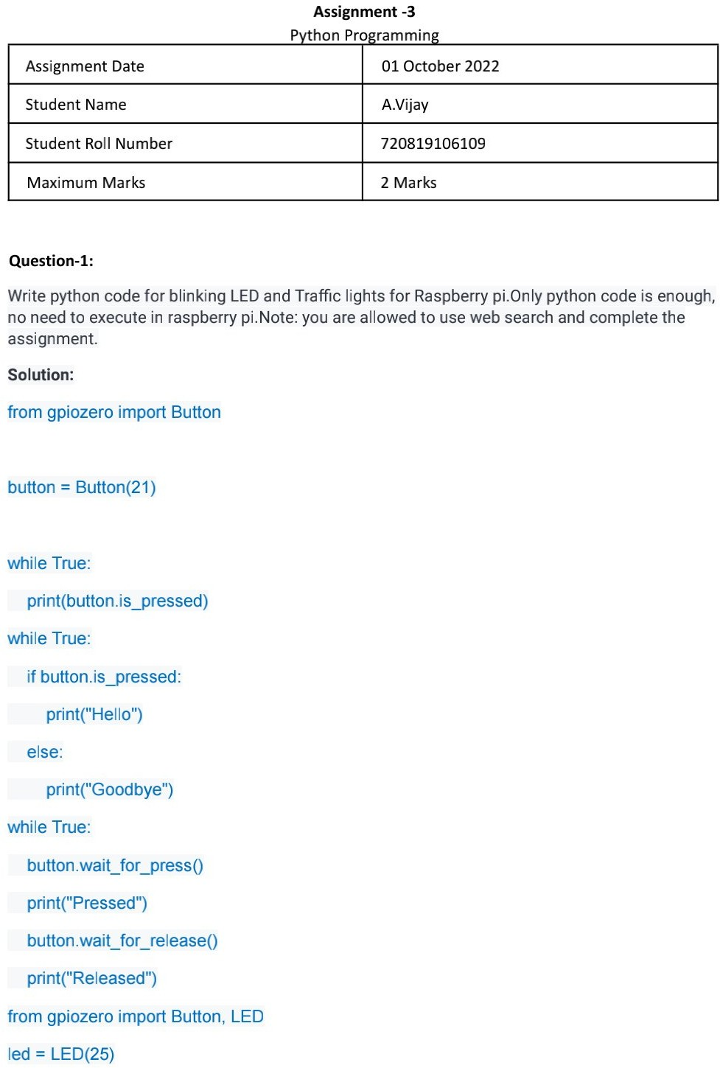

110719106039

Y Balaji

Y Balaji

110719106039

2 Marks

110719106039

Y Balaji

01 October 2022

